2009: Various Parties in and around Bangkok.
Perfect sports Bar: Soi 614 Ramkanmhaeng Rd. Minburi. Bangkok
Halloween party 31st October 2009
Burapa Bike Week: Pattaya 12th February 2010
Perfect Sports Bar: 1st birthday Party with Desktop Error. 1st May 2010
18corner6: Lad Phrao Rd. Soi 18
Friday nights from June 2009-2010 (acoustic)
Blue Monkey Bar: Soi 164 Ramkamhaeng Rd. Minburi Bangkok
Various acoustic sessions May 2010-now.
Colorful peace and love Concert: Siam Square Bangkok
Main stage 16th July 2010
No Space Gallery: No Space Gallery RCA Bangkok
Headline act 31st July 2010
Lad Krabang University: celebration of the arts festival
National Art Gallery : ` opposite MBK
Headline Act
JJ Markets: Mo Chit Bangkok
Acoustic and Electric sessions 2011.
V64 Art Gallery: Music and Arts festival September 2011
Albums released: Live studio Demo with 6 songs. Recorded Minburi Bangkok.
Lao Cow (Psycho Deli )Recorded DBS Studio Lad Phrao and engineered by Koichi Shimizu
Videos available on Youtube just search Lao Cow.
Songs available at laocowmusic@myspace.com
Contacts: Mic Britten Mb: 0800740346 Email: brickmitten@yahoo.com (English)
Adisak Poung Ok (Bird) Mb: 0876163290 (Thai)

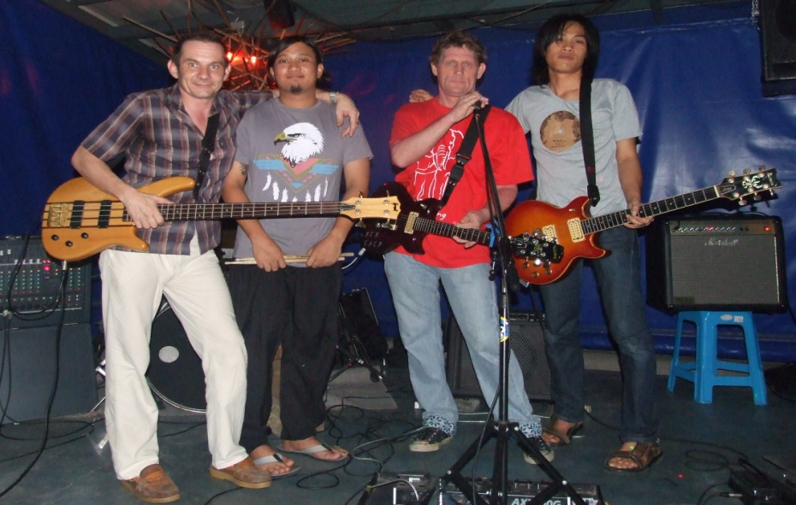

Lao Cow Formed in 2008 under the then name of Up2You, with a few catchy tunes written by songwriter Mic Britten. Since then the band has developed and grown into a rhythmic rock band that is able to deliver its music both acoustically and electrically to please large and small audiences alike.
Predominantly a rock band the bands unique blends of rock, pop and punk with slight folk undertones has already played to audiences on big stages such as the Burapa Bike weekend in Pattaya and the Colourful peace and love concerts at Siam square Bangkok.
Australian rhythm guitarist and vocalist Mic Britten comes from a punk rock and pop background having played in various bands in Perth West Australia throughout the 1990s. He has a powerful distinctive rock voice that also lends itself nicely to mellow slow songs.
Guitarist Adisak Poung Ok (Bird) is a native of Thailand who is no stranger to the Thai music scene as a guitarist for Desktop Error and a highly acclaimed individual presence in the local scene. His guitar stylings influenced by both British indie sounds and American rock blues add a sound that make Lao Cow feel familiar yet refreshingly new.
Gerhard Weissenboeck on bass has added his special blend of traditional Austrian/German folk to this rock outfit. Having extensive experience playing both folk and cover music throughout Europe he has developed a bass style that rocks out when needed to with Lao Cow.
Drummer Aok Chaitep a local Thai is the final brick that builds this band. Originally a folk guitarist and singer his adaption to a drummer has been a cornerstone to the unique rock sounds of Lao Cow. His drumming is enough and more to keep the band flowing as well as adding truly great signatures that make Lao Cow.

