
PROFILE: AMAMERE FOLK MUSIC & DANCE ENSEMBLE is a cultural organisation under the tutelage of AMAMERE CONCEPTS LIMITED and based in Accra. We are an organisation with the mission of propagating and promoting the cultural values and heritage of Africa through traditional music dance & drama, with more emphasize on Ghana. Formed some 15 years ago, this group has undergone several changes since formation and now maintained new name Amamere Concepts Limited (registered).


Quaye Lawrence
Artistic Director
Badu Evans
Coordinator
Affiliations:
Centre for National Arts & Culture, National Commissions on Culture-Accra, Ghana Dance Association, Ghana Monument Board, Ghana Export Promotion Council, and International organisation of Folk Arts (I.O.V)-Austria. C.I.O.FF- USA. International Folk festival Organise, UK. West Africa Rep of Leading University of Dance Theatre & Show Organisation, Italy.
Amamere Group Members
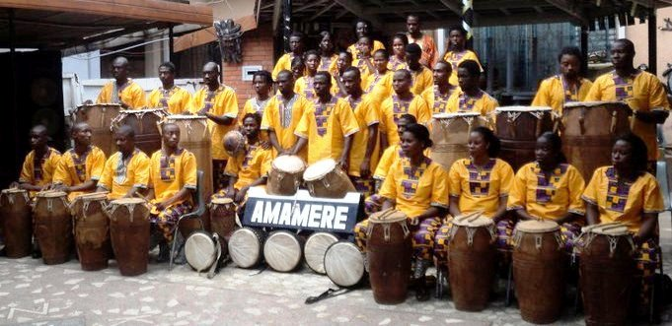

Contact: BADU EVANS (Co-ordinator)
AMAMERE FOLK MUSIC & DANCE ENSEMBLE
BOX AT 2209, ACHIMOTA MK, ACCRA-GHANA
E-Mail: amamere_concepts@yahoo.co.uk / evansinging@gmail.com
Tel: +233-302-228292. Cell: +233248194568
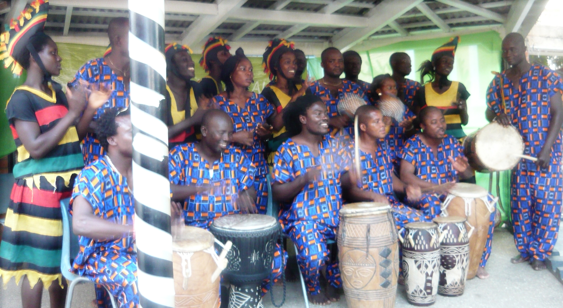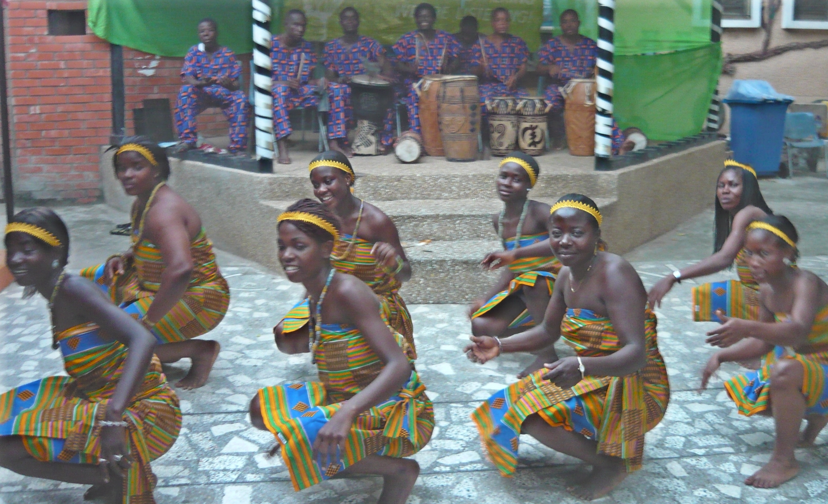
INTERNATIONAL FESTIVALS:
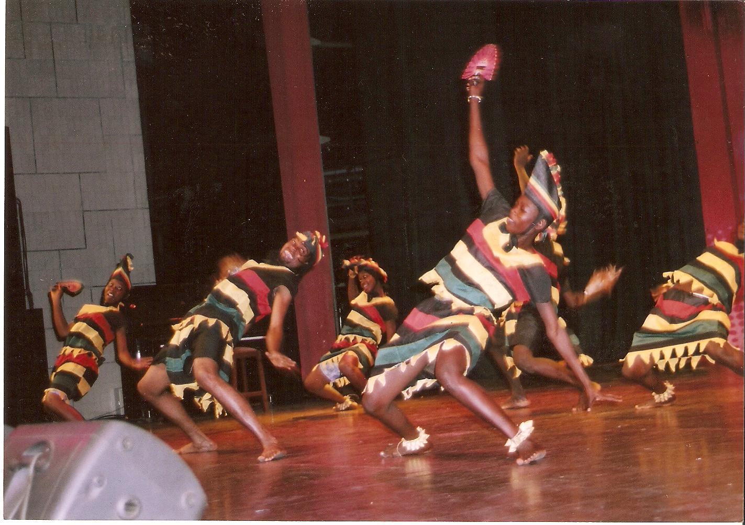
- In 2002, the group attended Gala Del Folklore Festival in Messina, Italy. After which we had a tour from Southern Messina to Northern Bergamo, performing in 24 cities in 28 days.
- In 2003, we performed at SIDMOUTH International Festival, Devonshire, England.
- In 2004,back in Italy for an International Folklore Festival in Italy, Citareale, Tour Roma, Termoli, Alatri, Bacelonese Mango, Gravina in Puglia etc.
- 2005 in Alnwick International Music Festival-Northumberland-Newcastle, UK.
- 2006, we participate in 34TH International del Folklore Festival in Petrallia Sottana, Tour Catania, Etna, e.g. all in Palermo-Cecilia.- Italy.
- 2007, 45th International cultural dance festival-Togo
- 2008: International Jazz / Folklore festival –Accra
- 2009-June - July, Ghana Dance World Cup Ambassador to Canada (www.danceworldcup.com).
- 2009-August, International folklore festival (city of Serres folk fest) Greece
- 2010-Jutajaiset International Festival-Finland
- 2011- Batumi in International Folklore Festival tour, 16 - 28 July 2011.
- EXPO AMERICAS 2011in Baltimore, Maryland-USA.-21-28, October
- Mercin International Citrus festival in Turkey (16 - 21 Nov, 2011),
- 2012 - Biogas cultural Exhibition-Bremen, Germany 09-15/01/2012
- Tbilisi Inter cultural Exchange –Tbilisi-Georgia (18-29/02/2012)
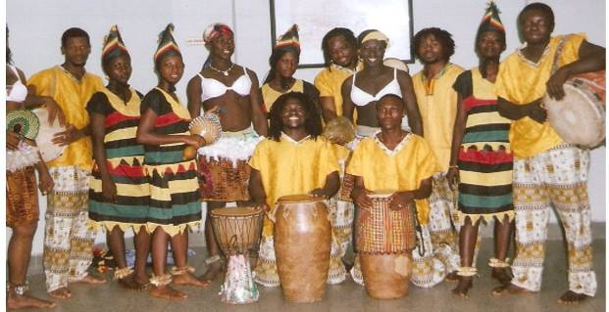

Web links:
- http://amamerefomdanensemble.ning.com
- http://www.bebo.com/amamere-Concepts-ltd
- http://www.alatrifolkfestival.it/animazioni/animazioni_04/ghana.swf
- http://www.facebook.com/home.php?filter=app_2305272732#/album.php?aid=187784&id=1498125267

2004 Italian Tour:
16 - 24 JULY= 5TH INTERNATIONAL FESTIVAL DEL FOLKLORE COREDO IN TRENTO.
25 - 29 JULY=4TH INTERNATIONAL FOLKLORE GRAVINA IN PUGLIA, PROV.OF BARI.
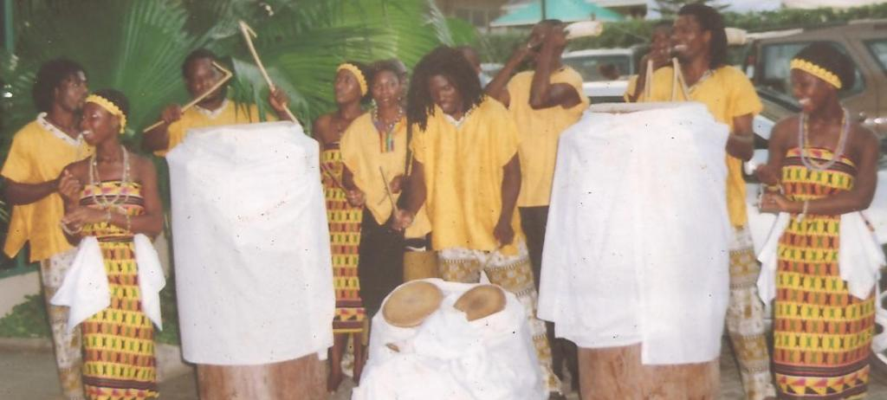

29 - 3RD AUG=VALLE DI COMINO FOLK FESTIVAL ATINA,PROV.FROSINONE.
4 - 8 AUG=INTERNATIONAL FESTIVAL FOLKLORE,TERIMOLI PROVINCE OF ROMA,

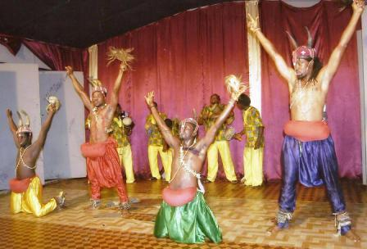

9 - 16TH=GRUPPO FOLK ARIA DE CASSA NOSTRA ALATRI, PROV. OF FROSINONE.
18 - 26 AUG. INTERNATIONAL FESTIVAL FOLKLORE, CITAREALE, PROV.OF REATI.



